Healthwatch Hackney delivery schedule – April 2024 – March 2025
Table one shows the full schedule of activity for the core Healthwatch Hackney activities (directly funded by the core LBH Healthwatch grant). Table two shows the range of projects and activities additionally to be undertaken by Healthwatch Hackney in 24/25 (although not directly funded by the LBH Healthwatch grant, the grant can be considered an enabler to these projects, as they would not take place without the council grant.

Table one
Reports | Signposting/comments collected/social media/comment collection | Other Activities
Enter and View of Inpatient Mental Health Wards (ELFT)  5 visits to wards completed. Repeat visit – to 3 wards to collect additional patient feedback, and visits to 2 additional wards undertaken.  Visits  Ward Final reports June/July 24  Overarching report into the visits to ELFT mental health wards undertaken.  GP registration (to track whether GPs in Hackney are following rules around not asking for/requiring proof of ID or address to register patients) – 4th iteration. Final report May 24  Mystery shopping of Adult social care. Callers will enquire about support available for an elderly vulnerable relative.  Quarterly insight reports –  - patient experience of health and care services  - primary care services  - Homerton Hospital  Experience of services for patients living with sickle cell disease ,including primary care and Homerton hospital. Final report date TBC  Adult Social Care – Front door user experience – mystery shop. To include safeguarding  Complaints Charters – reviewing and updating all complaints charters including GPs, dentists, Homerton, ELFT  Enter and Views TBC (ad hoc in response to patient feedback) | Record number of signposting activities including complex signposting  Record social media followers – Facebook, Twitter, Instagram  Record number of comments collected from residents/patients  Record number of volunteers  Record number of outreach sessions for comment collection (minimum 24 in 12 months) | Information Exchange x 6  Newsletter x 12  Public Board Meetings x 4 (to be held in person)  Healthwatch Hackney Annual Report published 30th June  HWH AGM  Volunteer summer gathering for Volunteer week 3rd – 9th June  Volunteer festive gathering Dec 24  Complete HWH 24-27 strategy  Agenda item/presentation at all Hackney Health and Wellbeing Boards  Attend and contribute to:  - Health in Hackney Scrutiny Commission  - City and Hackney Health and Care Board  - Health Inequalities Steering Group  - Homerton Patient Safety Committee  - Hackney Carers Strategy working group  - NEL ICB  - People and Place  - Primary Care Enabler Board  - Health and Wellbeing Board social isolation subcommittee  - Social capital advisory board  - Health and wellbeing boards joint sub committee sexual and reproductive health strategy oversight group
Updates  All the visits to the seven ELFT mental health wards have been located in Homerton Hospital have been completed.  Reports have been completed for 5 wards with the remaining ward reports nearly complete. The completed reports have been reviewed by the ward matrons and are currently under review with ELFT senior management.  The 4th GP registration review has been completed and published.  Work research sickle cell disease has started in preparation for report on patient experience.  The complaints charters are currently with the designer.  Leading on the design of a system wide calendar, through the comms and engagement enabler group (chaired by HWH Executive Director). A list of members/contributors has now been compiled, with an agreement to hold the professional facing comms and engagement calendar on the HWH website. | We have 649 followers on Instagram. In the last 90 days we reached 601 accounts.  We have 447 Facebook followers. In the last 90 days we had 198 content interactions.  A Threads account has been set up and we plan to leave X (Twitter). | Information Exchange meetings held on adult eating disorders and looking after your liver.  As well as the attendees the YouTube video on eating disorders has received 31 views and the video on looking after your liver 64 views.  4 Newsletter were sent between April and July, the average open rate was 37.7 and the average click rate was 6.3 which compares favorably to industry standards.  A volunteer gathering was held at the Peter Bedford Centre on 5th June to celebrate the contribution made by the HWH volunteers and public representatives. Daily video’s were also posted for Volunteers week.  The annual report was published at the beginning of July following the end of purdah.  Presentations and contributions provided by Executive Director at City and Hackney Health and Care Board  - Health Inequalities Steering Group  - Homerton Patient Safety Committee  - Hackney Carers Strategy working group  - NEL ICB  - People and Place  - Primary Care Enabler Board  - Health and Wellbeing Board social isolation subcommittee  - Social capital advisory board
Outcomes
I recently had a negative experience with a GP.
As a result of my positive interaction with Sara, I think it only fitting that I offer appropriate commendation.

I appreciated how quickly Sara responded to the message I had left, as this allowed me an element of closure, which was very much needed.

Sara permitted me to share my narrative without interruption, and despite my inconsistent chronology of the events she was able to collate the information and understand why I felt aggrieved, how the surgery could and should have done better, and what advice she would provide to them moving forward.

I requested her professional opinion regarding my options, and these were provided succinctly, which helped me decide immediately how I wanted to proceed with my complaint, and once decided upon Sara then provided further resources such as relevant email addresses, numbers, websites etc.

Although I was left with the tools to see this through on my own, Sara was kind enough to request that I contact her again, so that she can further facilitate matters should this be necessary.

I could not have asked for more, and would appreciate it, if you would extend my heartfelt appreciation to Sara for her kind and thoughtful assistance.
Qrt 2 -3 update  Mental health reports have been completed and published on 10/10. Sara and Sally met with ELFT senior management to discuss key findings and recommendations. ELFT commented that our evidence will feed into their quality improvement work. However, they did not formally reply to our reports. We will follow-up in the new year and seek to republish the reports updated with ELFT’s formal reply.  Following introductions by Fabien, Sara followed up on the GP registration review report with Shoreditch PCN asking all practices in the area to display the “no proof of ID, no proof of address” poster.  The complaints charters have been completed and approved by the signatories. They will be relaunched in the information exchange meeting on the 27th of November. Plans for distribution are in place and will start at the end of the month.  Sara drafted a complaints charter for opticians, too. This is being reviewed and will be added to the other charters.  Ad hoc enter and views include The Riverside Practice and Well Street Surgery.  The Riverside Practice report will be shared with the Board on the week commencing the 11th of November. Sara met the practice manager and clinical lead to discuss the recommendations. Some recommendations have already been implemented: the practice now has a dedicated breastfeeding room, a clock on the wall and a new, accessible “new patient questionnaire”.  The Well Street report has been shared with the practice manager and we are awaiting a formal reply. Sara met with the practice manager to discuss the visit findings and recommendations and is working collaboratively with the practice manager on an implementation plan. The report will be ready for publication at the end of November.  Further enter and views have already been planned up until March. The next one will be at Trowbridge Surgery on 26 November.  Sara, Sally and Catherine are in conversation with Adult Social Care regarding the mystery shopping. Two meetings were held. Further work is pending on ASC clarifying their aims and objectives. | Qrt 2 -3 update  In Q2 and Q3 we collected 167 comments in 11 outreach events. 3 more outreach sessions are planned for November and December.  The number of volunteers remains unchanged at 78. New people have joined but some volunteers have left as they are now in employment. | Qrt 2 -3 update  An Information Exchange meeting was held on 25 September on blood donation. In addition to the participants, the meeting had 12 views on our Youtube channel.  The next information exchange meeting will be held on 27 November on complaints.  The Christmas festive gathering will be on the 11th December at the Peter Bedford House Association.  Information Exchange meeting on 27/11/24 on the complaints charter, to relaunch the charter. Guest speakers from Re-think and ICB complaints. Members of the public and system staff attended and the recording will be live on our Youtube channel.  Open rates for the newsletter are higher than average (usually around 40 - 45% open rate). Based on a circulation of 964 subscribers.

Table two
Project | Key objectives
Neighbourhoods | Working in partnership with VCH and HCVS to support residents to take part in Neighbourhoods forums, facilitating resident engagement through forums and other involvement activities within Neighbourhoods.  The production of 8 insight reports – one per Neighbourhood – sharing all insights gathered by Neighbourhood to inform hyper local services and Neighbourhood planning
Neighbourhoods Q1 updates/outcomes | - All 8 Neighbourhoods Insight Reports finished and updated with required branding. These are now on the Neighbourhoods website and are being shared with local professionals and members of the public.  - Survey requiring feedback on Insight Reports produced, to be disseminated throughout list of Neighbourhoods staff by Neighbourhoods comms team.  - Attendance to multiple Neighbourhoods Alliance Partners’ meetings.  - Support of HCVS in interviewing and selecting 2 x new facilitators. These are now in training.  - Attendance / support of first patient-led ‘Action Groups’ in Neighbourhoods.  City & Hackney online resident engagement staff drop-in surgery delivered on: "Using QR Codes in Resident Engagement" – and “Engaging with seldom heard communities”. Slides also shared with staff across C&H.
Neighbourhoods Q2/Q3 updates/outcomes | Neighbourhoods Programme – HWH Update 2024  Quarter 1 Summary: Neighbourhoods Project  - Staff Recruitment and Support:  - Supported recruitment of two new Neighbourhoods facilitators.  - Community Engagement:  - Attended Well Street Common Neighbourhood Forum.  - Participated in and supported Springfield Park Action Group.  - Resident Engagement Surgeries:  - Hosted three online resident engagement surgeries (informal drop-ins) on the last Wednesday of each month to support staff city-wide in Hackney.  - Topics included:  - Increasing diversity.  - Using QR codes for engagement.  - Correct / ethical recruitment and management of volunteers.  - Publications and Documentation:  - Proofed, edited, and updated branding for:  - Eight Neighbourhoods Insight Reports.  - Eight corresponding executive summaries (shorter versions of the reports).  Quarter 2 + 3 Summary: Neighbourhoods Project  - Community Presence and Engagement Events:  - Healthwatch Hackney presence at Daubeney Fields Community Funday, which served as the Well Street Common Neighbourhood Forum.  - Tote goodie bags distributed to residents + toys to younger children.  - Attended Hackney Downs Neighbourhood Forum.  - Conducted resident interviews to gather feedback.  - Provided three interview transcripts to partners at HCVS.  - Planned support for two upcoming Neighbourhood Forums:  - Springfield Park Neighbourhood Forum on Sunday, December 1st.  - Well Street Common Neighbourhood Forum on Monday, December 3rd.  - Springfield Park Neighbourhood:  - Participated in additional action group meeting for Springfield Park.  - Discussed + decided on theme of December Forum: Connecting Different Communities, focusing in part on inclusivity for Jewish Orthodox Charedi community.  - Clarified need for two forums rather than one to ensure better engagement.  - Coordinated efforts to encourage attendance from Charedi community members to ensure inclusivity at Forum.  - Accessibility Support:  - Organised travel assistance for disabled residents to attend action groups and Neighbourhood forums.  - Resident Engagement Surgeries:  - Hosted four additional online resident engagement surgeries for professionals across Hackney.  - Topics included:  - Understanding co-production.  - Collecting demographic data.  - Identifying and supporting carers (with a presentation from Carers First).  - Effective production and execution of DBS checks.  - Collation and Monitoring of Engagement Data:  - Met with various engagement staff across Neighbourhoods to begin collating engagement data and insights.  - Developing Excel spreadsheet to produce directory of opportunities and evidence to link services to resident groups for feedback on improving services (ongoing work).  - Supporting Forums in collating and analysing resident insights.  - Neighbourhood Leadership Group Meetings:  - Attended six neighbourhood leadership group meetings to present that Neighbourhood’s Insight Report to partners.  - Shared full Insight Reports and Executive Summaries for each respective Neighbourhood.  - Created and distributed survey for professionals to provide feedback on reports, aiming for improvements in next year’s iteration.  - Addressing Data Gaps in Insight Reports:  - Addressing data gaps in initial iteration of Insight Reports.  - Established data contacts with the below services, to obtain missing data:  - East London Foundation Trust (mental health data).  - Adult Social Care services.  - Citizens Advice.  - Social Prescribing services.  - City and Hackney Stop Smoking service.
Engagement and Coproduction | Supporting approx. 45 Public Representatives from a diverse range of backgrounds to get involved in a wide variety of coproduction projects. Examples of projects include:  - Engaging with specific communities to understand low uptake of breast screening  - Coproduction work creating user friendly flyers for the homeless/digitally excluded community identifying free services for local residents  - Engagement around risk assessments for those affected by domestic violence – what should risk assessments for the LGBTQIA+ community include  - Coordinating and delivering system wide coproduction community of practice  - Coordinating ICCEEG
Engagement and coproduction quarter one updates/outcomes | Personalised care patient passport book launch: a physical passport style booklet for the patient, system partners and community orgs to work from - these will be for adults with extra care & support needs, long-term medical conditions etc. This will mean that those holding a personalised care passport will have an improved sense of ownership, understanding and autonomy around their care plans. They will not need to keep repeating information to different care providers, and the passport will facilitate greater alignment between care providers around the care plan.  Steps – coproduction group with adults with complex needs including homelessness, mental health and substance misuse. Created a non-digital physical double A4 flyer directing residents with complex needs to appropriate support including food banks, lunch clubs, mental health support and social connectivity support. The flyer, now widely available across Hackney, will allow residents that do not have access to internet to learn about and tap into vital services for their wellbeing.  Discharge Steering Group – consultation/engagement sessions with reps – Homerton is introducing a new incoming/discharge patient checklist form. The form will be completed when a patient is admitted, to flag any issues that may come up around discharge early. This will allow hospital staff to tackle any issues (which could include things like home not being fit to return to, no electricity at home, abusive situation at home). By gathering this information much earlier in the process the hospital can begin putting solutions in place by contacting the appropriate services. This should mean much smoother, better supporter, swifter discharges when the patient is ready to return home.
Engagement and Coproduction Q2/Q3 updates | 42 public reps. 293 volunteering hours. 27 Focus Groups 6 Training Sessions 11 integrated partnership meetings. 9 streams of work including co-production of Hackney Carer’s strategy work.
Father Friendly Borough | A coproduced needs assessment (working with approx. 15 experts by experience) to understand the needs of fathers, particularly from the Black/Black mixed heritage community, Orthodox Jewish Community and Turkish Speaking Community, in relation to perinatal mental health for fathers and parent/infant relationships.  The work will produce a comprehensive report highlighting what is already available for fathers and where the gaps in services lie. The experts by experience will work with Healthwatch to formulate recommendations for service change and improvement. They will continue to work with Healthwatch to support the action plan/implementation of recommendations.  Healthwatch is working in partnership with grassroots organisations including Father to Father, Derman and the Lubavitch Centre to undertake engagement, and through the action plan will support various VCS organisations to understand and better deliver support for perinatal mental health in fathers and parent enfant relationships
Father Friendly Borough Quarter one updates/outcomes | The FFB team worked together with EbEs to co-design:  - Survey asking fathers in Hackney about their fatherhood experiences, experiences of using the local health and care services, father’s level of preparedness for fatherhood and their support needs (if any) and expectations from services.  - Sub-contracted 3 Community organisations to conduct surveys and focus groups with the fathers of the communities they serve.  - Co-production of a survey designed for service providers asking organisation about their level of engagement with families and fathers specifically, type of support provided, e.g group sessions or signposting; organisations’s needs to provide further support to fathers, e.g further training, funding  - Weekly Coffee Morning for fathers in Hackney – a place where any father can meet the FFB team and other fathers, to find out more about the project, to share experiences and receive signposting information about local services available. The venue (46b Espresso Hut, E9 6DF, near HUH) was strategically selected to allow fathers accompanying their partners at Homerton Hospital to join in. Up to date, there are 17 sessions delivered.  - Intensive outreach all over Hackney including 21 children’s centres, GP practices, community events and festivals, local libraries, local shops and barber shops, leisure centres etc.  - Over 350 surveys completed by local fathers  - 5 focus groups with local fathers  - Interim report based on father’s feedback  Engagement to continue until 23rd of August  Started the draft of the final report due to be ready in Sept 2024.
Father Friendly Borough Q2/Q3 updates and oucomes | Over 900 local dads have engaged with us through surveys, focus groups, 121 interviews and sign-posting conversations.  Needs assessment report (phase one) close t completion and will be launched in December.  See below for some of the activities associated with the programme  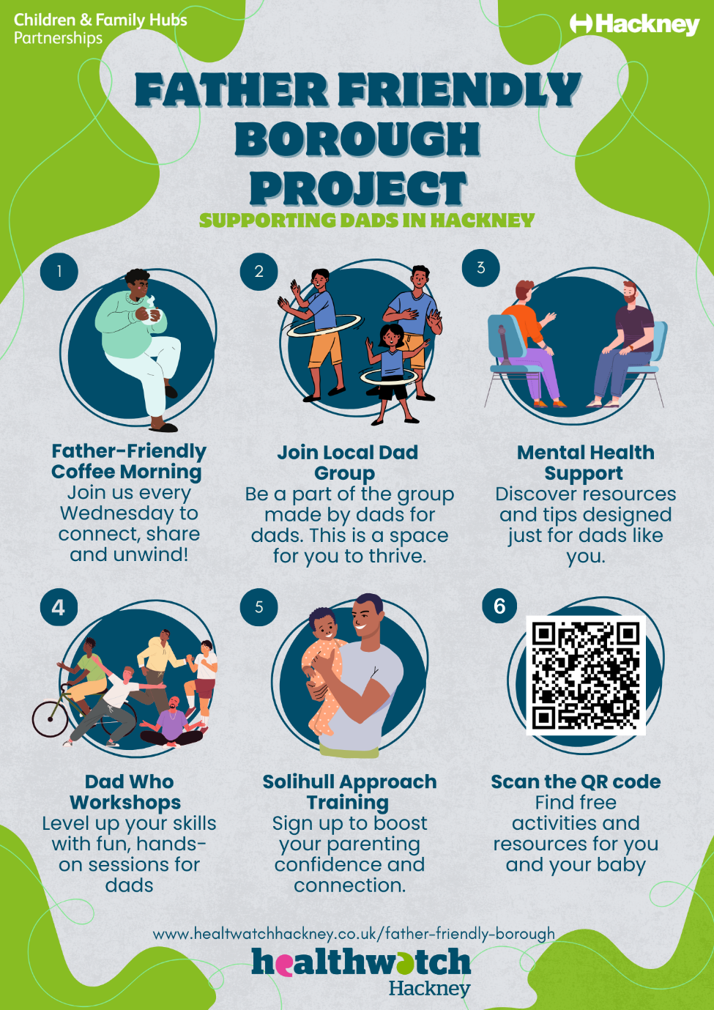  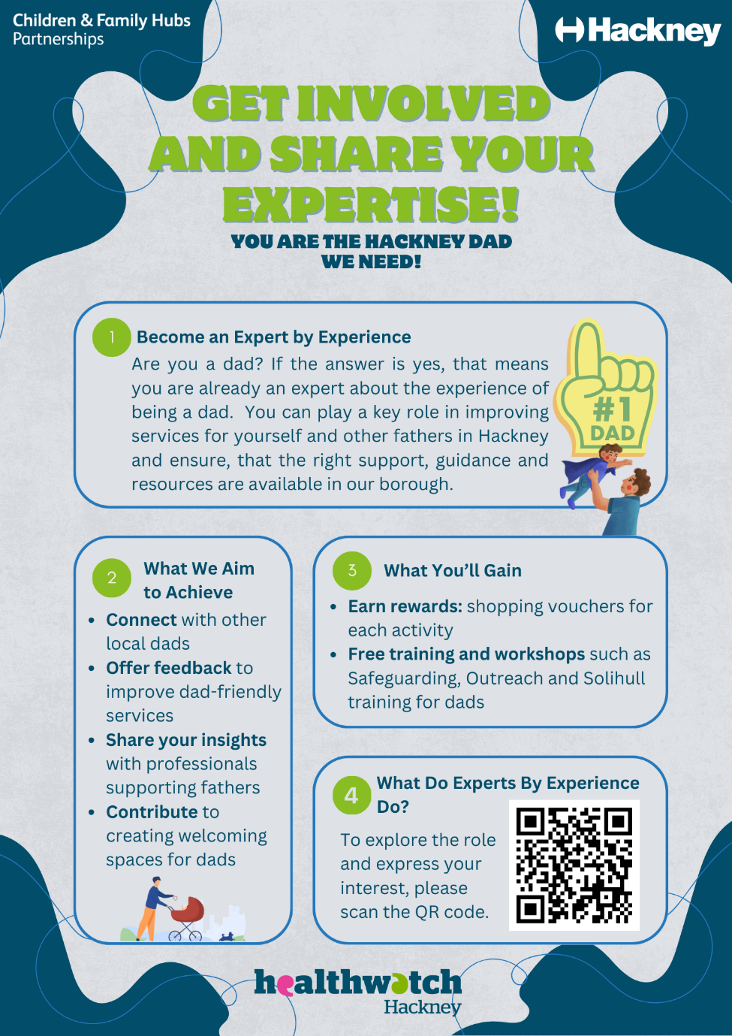
System Influencers | Working with young people (age 16 – 24), the programme pairs local young people with system mentors to enable genuine coproduction. The project supports 10 young people per iteration, with 3 iterations across 12 months. Projects to date include:  - MATCH – Tackling period inequality for young people – delivering peer led sessions in primary schools as well as coproduced engagement  - LBH Carers strategy – coproduced, peer led engagement with young carers  - Super Youth Hubs – coproduced development and peer engagement for the Super Youth Hubs
System Influencer quarter one outcomes/updates | The SI Programme successfully wrapped up its first iteration of 2024. In April, three projects—Period Match, Young Careers, and Super Youth Hub—presented their impressive concepts, receiving positive feedback, with one project potentially being permanently rolled out.  In May, the next iteration began, bringing on board fifteen Influencers and four Mentors/projects. This phase is still ongoing until September. The influencers are working on projects tackling immunisation, anti-racism, developing a more comprehensive and youth-centric approach to healthcare for young people and making changes to young people’s health literacy.  Unfortunately, halfway through this iteration, 4 influencers left the programme but the remaining 11 remain committed. The showcase event for this iteration will take place on 4th September at St Joseph’s Hospice. We are currently recruiting for the next round.
System Influencer Q2/Q3 outcomes/updates | Second iteration completed with a wonderful showcase of the young people’s work at St Joseph’s (see below)  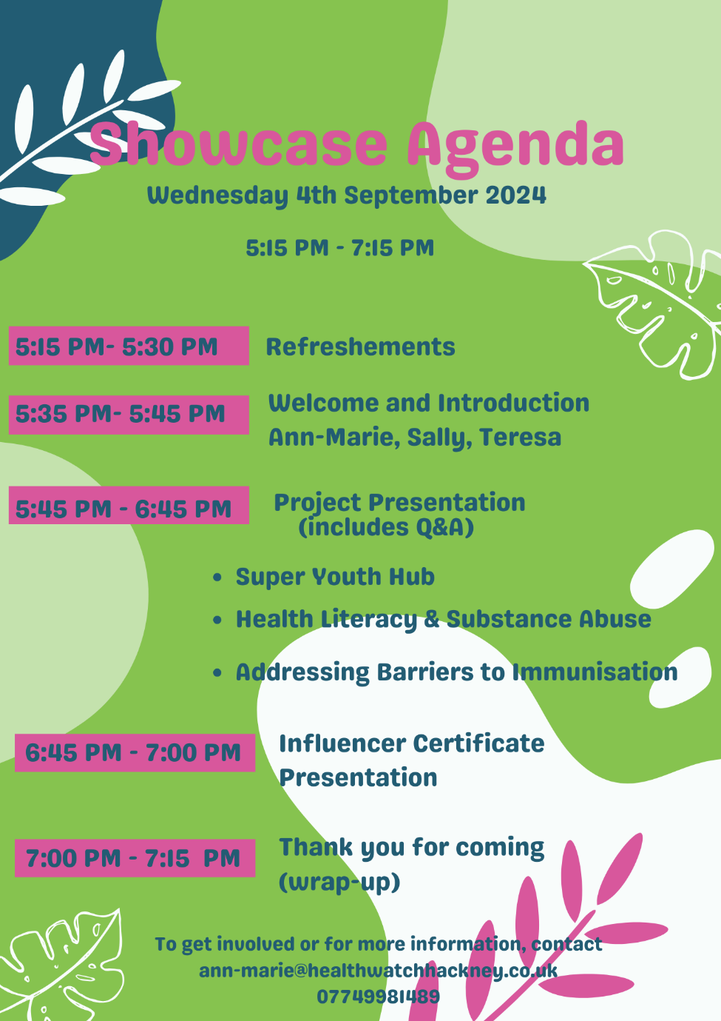  We are working with 16 young people as we draw to the close of the final iteration of this round. The showcase will be held Jan 25, where we hear about the young people’s work around sexual health, smoking cessation, mental health and health spots.
Learning Disabilities Quality Checkers project Q2/Q3 | LD QC Project - 2024  Background and Context  - Previous Project: The Community Voice Project (2023-202) focused on improving annual health checks and enhancing health equity for learning-disabled (LD) individuals, with a particular emphasis on addressing social isolation.  - Current Project: The LD Quality Checkers Project, commissioned by the London Borough of Hackney, aims to assess and improve accessibility and inclusivity in healthcare settings for LD patients in Hackney.  Project Details  - Timeline: 12 months (starting May 2023), with 10 visits planned across primary, secondary, and social healthcare settings.  - Setup and Preparation: Consultation with Tower Hamlets’ similar project, use of inherited documents, and recruitment/training of LD Quality Checkers through co-designed + scenario-based training sessions.  - Team Structure: Led by FD, with 2 LD Quality Checkers per visit (4 in total)  - Focus Areas: Accessibility; inclusivity (e.g., environment, signage); patient experience.  Methodology  - Pre-Visit Preparation: Allocation of QC roles and responsibilities during pre-visit meeting.  - Visit Activities:  - Active participation of quality checkers in asking pre-assigned questions and making observations.  - Engagement with staff, including practice managers and LD specialists, to discuss inclusivity measures.  - Post-Visit Reflection:  - Informal debrief sessions with quality checkers to review notes, impressions, and feelings about how staff answered questions.  - All feedback is recorded for insights and inclusion in the final report.  Key Values  - Emphasising Quality Checker Voices: Reports include direct quotes from quality checkers, capturing their individual perspectives and impressions.  Progress So Far  - Visits Completed:  - 3 GP Practices: De Beauvoir Surgery; Latimer Health Centre; Lower Clapton General Practice.  - Day Centre: Outwood Hub Club for learning-disabled individuals.

